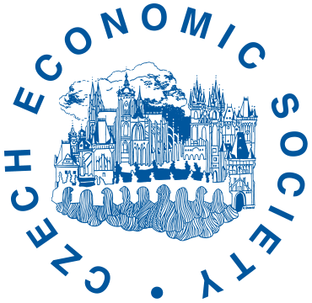
The Laureate of the Kateřina Šmídková Prize
is
Monika Mrázová

Prague, 26th November 2022
The winner of this year’s Kateřina Šmídková Prize, awarded by the Czech Economic Society (CES), is Monika Mrázová, professor at the Geneva School of Economics and Management (GSEM), University of Geneva, and research fellow in CEPR and CESifo. Professor Mrázová focuses mainly on international trade, political economy, and industrial organization.

The Kateřina Šmídková prize is awarded by the Society in memory of Czech economist Kateřina Šmídková, a long-time member of the CES’s board of directors, a professor of economics at IES FSV UK and the director of economic research department at the Czech National Bank. The purpose of this prize is to award Czech and foreign female economists living in the Czech Republic for a long period and engaging in exceptionally high-quality publishing activities with support for their further professional progress. The prize is accompanied by a monetary award of 100,000CZK, and is financed from the funds bequeathed by Professor Šmídková. These funds are managed by the Kateřina Šmídková Trust.
Monika Mrázová works as a professor at Institute of Economics and Econometrics, Geneva School of Economics and Management, University of Geneva. Since 2013, her academic career has been connected with the University of Geneva. She has also worked as an assistant professor at School of Economics, University of Surrey (2011–2013) and as a postdoctoral research fellow at London School of Economics (2009–2011). From September 2022 to June 2023, she is a visiting professor (Peter B. Kenen Fellow) in the International Economics Section and the Department of Economics at Princeton University. After graduating from Ecole Centrale Paris and Vienna University of Technology (Dipl.-Ing.), she obtained a master’s degree at the London School of Economics and Political Science (MSc.) and defended her dissertation at the University of Oxford. Her main areas of interests are international trade, political economy, and industrial organization.
Monika Mrázová is considered to be one of the top-rated Czech economists abroad. She received more than 700 quotations in Google Scholar. Her work is published in the most prestigious academic journals in economics: Econometrica, American Economic Review, Journal of the European Economic Association, Economic Journal, Journal of International Economics and International Economic Review.
The prize was awarded on 26th November 2022 during the 12th biennial conference of the Czech Economic Society, which was held at the Prague University of Economics and Business. The prize was ceremoniously presented by Daniel Münich, President of the CES, and Milena Horčicová, a member of the Committee for the Kateřina Šmídková Prize.
For more information about the prize, visit the Czech Economy Society’s web site: https://www.cse.cz/en/page/katerina-smidkova-prize

Contact for journalists
Daniel Münich, president of the CES, tel: +420 224005175, munichd@gmail.com
Daniel Němec, chairman of the prize committee, tel: +420 725175530, daniel.nemec@econ.muni.cz
Kamil Galuščák, member of the CES board in charge of media relations, tel: +420 22441 4580, kamil.galuscak@volny.cz

Note for editors
The Czech Economic Society (CES) is a civic association of professionals and supporters of the field of economics. The main mission of the CES is to help the development and popularisation of the economy in the Czech Republic in a way that respects and supports opinion plurality and the independent development of economics courses. The CES is a member of the Council of Scientific Societies of the Czech Republic.

