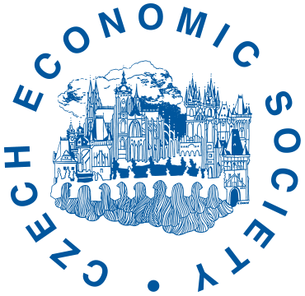
The Czech Economic Society Prize
for Long-Term Contribution to the Development
of Czech Economic Learning

Prague, 26th November 2022
The winner of this year’s CES Prize for long-term contribution to the development of Czech economic learning is Avner Shaked, visiting professor at CERGE-EI since 1998 and member of the Executive and Supervisory Committee of CERGE-EI since 2000.
Prof. Shaked is one of the world’s leading economist considered the foremost expert in game theory, theoretical industrial organization and microeconomics. He is guru of modern game theory and industrial organization theory in the Czech Republic, he contributed to the education and formation of new generations of economists. Prof. Shaked is member of the Scientific Advisory Board of the Czech Science Foundation since 2019.
The prize is awarded by the Czech Economic Society (CES) to outstanding representatives of the Czech economic community for long-term contribution to the development of Czech economic learning. Prof. Shaked is the ninth winner of this prize. This year’s prize is awarded for long-term and versatile support to the development of economics in a scientific way in the Czech Republic.
Before his engagement in CERGE-EI, prof. Shaked acted as a professor of Economic Theory at the University of Bonn, Germany (1989-2009). He was also professionally active in Nuffield College of University of Oxford between years 1972-1974, and at London school of Economics in 1977-1989. He acted as a visiting professor at Princeton University, New York University, University of California, Tel Aviv University, University College London or Utrecht School of Economics.
Prof. Shaked was a member of editorial board of Review of Economic studies in 1982-1993. He acted as an associate editor in Quarterly Journal of Economics in 1988-1991 and in Journal of Economic Theory in 1993-1995. Papers of prof. Shaked were published in number of significant economy journals, such as Econometrica, American Economic Review, The Quarterly Journal of Economics or Review of Economic Studies.
Prof. Shaked was awarded the prize on 26th November 2022 during the 12th biennial conference of the Czech Economic Society at the premises of Prague University of Economics and Business.
More information about the prize is available at:
https://www.cse.cz/en/page/ces-prize-for-long-term-contribution-to-development-of-czech-economic-learning

Contact for journalists
Daniel Münich, president of the CES, tel: +420 224005175, munichd@gmail.com
Svatopluk Kapounek, coordinator of the CES prize, tel: +420 739348954, svatopluk@kapounek.cz
Kamil Galuščák, member of the CES board in charge of media relations, tel: +420 224414580, kamil.galuscak@volny.cz

Note for editors
The Czech Economic Society (CES) is a civic association of professionals and supporters of the field of economics. The main mission of the CES is to help the development and popularisation of the economy in the Czech Republic in a way that respects and supports opinion plurality and the independent development of economics courses. The CES is a member of the Council of Scientific Societies of the Czech Republic.

