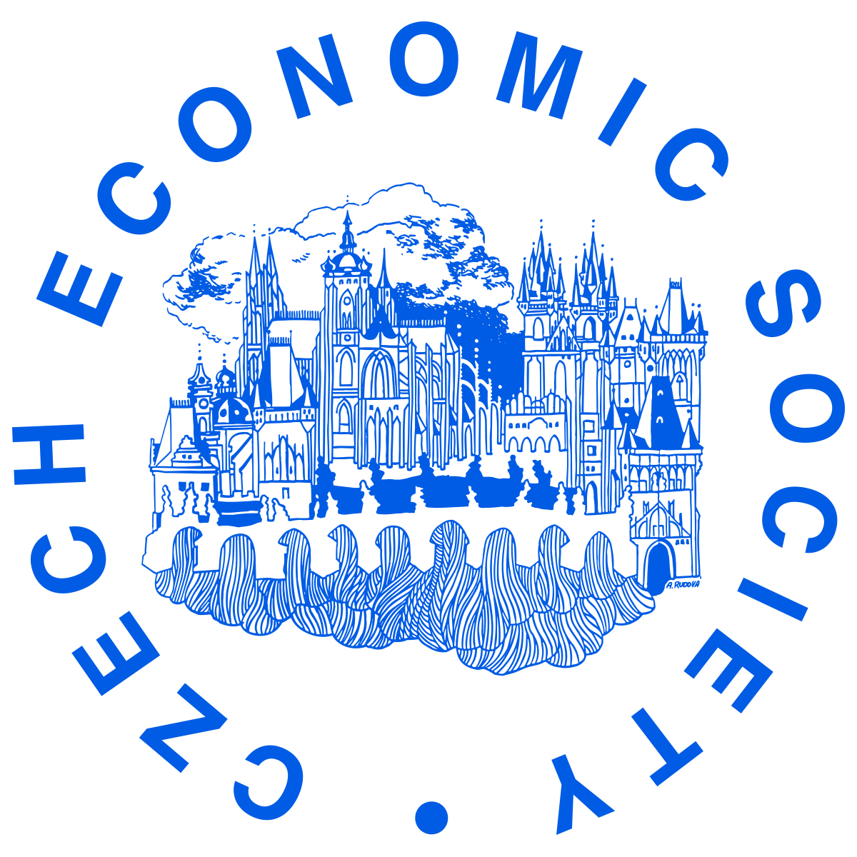 | Application form for the 30th Young Economist of the Year Award
AUTHOR
Name and Surname: … |  | Degree Course: Bc., Mgr., Ph.D., not studying (select appropriate)
Citizenship: … |  | Tel.: …
Age on October 8, 2023: … |  | E-mail: …
Academic institution where the
paper was written: …
PAPER
Paper title:
Keywords:
JEL Classification:
Co-authors (age):
The Czech Economic Society calls for applications for the 30th Young Economist of the Year Award. Applications are open to citizens of the Czech Republic, and to citizens of other countries who are living, working or studying in the Czech Republic, aged 30 years or under (these conditions also apply to all co-authors).
Each applicant may submit only one scientific paper of their own work, which must include an abstract, keywords and JEL classification and be no longer than 30 pages (a maximum of 54,000 characters including spaces); please see the “Young Economist of the Year Award Regulations” at http://www.cse.cz/en/page/young-economist-of-the-year-award for further details.
The paper (without the author’s name) should be sent along with this application form and a short nontechnical summary of up to 100 words by e-mail to young.economist@cse.cz no later than October 8, 2023.
Winning applicants are obliged to present their papers briefly on the occasion of the announcement of the award at the occasion of the CSE General Assembly, which will take place at the end of November 2023 in Prague.

I hereby declare that I have read and noted the “Young Economist of the Year Award Regulations” and that the data I have provided in this application form are correct. I also confirm that I declare all co-authors participated in the paper. I give consent to the Czech Economic Society to process my personal data for the purposes of the competition.

Place and date ……………………………….……….. Signature ………………..…………………

Please visit http://www.aeaweb.org/journal/jel_class_system.html
Please indicate the age of each co-author separately in brackets after his/her name.

